**DAILY ONLINE ACTIVITIES SUMMARY**

|  |  |  |  |  |  |  |  |  |
| --- | --- | --- | --- | --- | --- | --- | --- | --- |
| **Date:** | **28-05-2020** | | | | | **Name:** | **Raksha S** | |
| **Sem & Sec** | **6th B** | | | | | **USN:** | **4AL17CS073** | |
| **Online Test Summary** | | | | | | | | |
| **Subject** | | **OS** | | | | | | |
| **Max. Marks** | | **30** | | **Score** | | | **22** | |
| **Certification Course Summary** | | | | | | | | |
| **Course** | **FullStack Webdevelopment** | | | | | | | |
| **Certificate Provider** | | | **Great learning** | | **Duration** | | | **45 days** |
| **Coding Challenges** | | | | | | | | |
| Problem Statement: 1. Write a C Program to bubble sort an array of integers in ascending order and display the sorted array and Number of passes performed for sorting  2. Write a Java program to implement Binary Tree using the Linked List | | | | | | | | |
| **Status:** YES, Completed all Programs | | | | | | | | |
| **Uploaded the report in Github** | | | | | **YES** | | | |
| **If yes Repository name** | | | | | <https://github.com/raksha05/Daily-Status>/Raksha-4AL17CS073/Raksha | | | |
| **Uploaded the report in slack** | | | | | **YES** | | | |

Online Test Details:

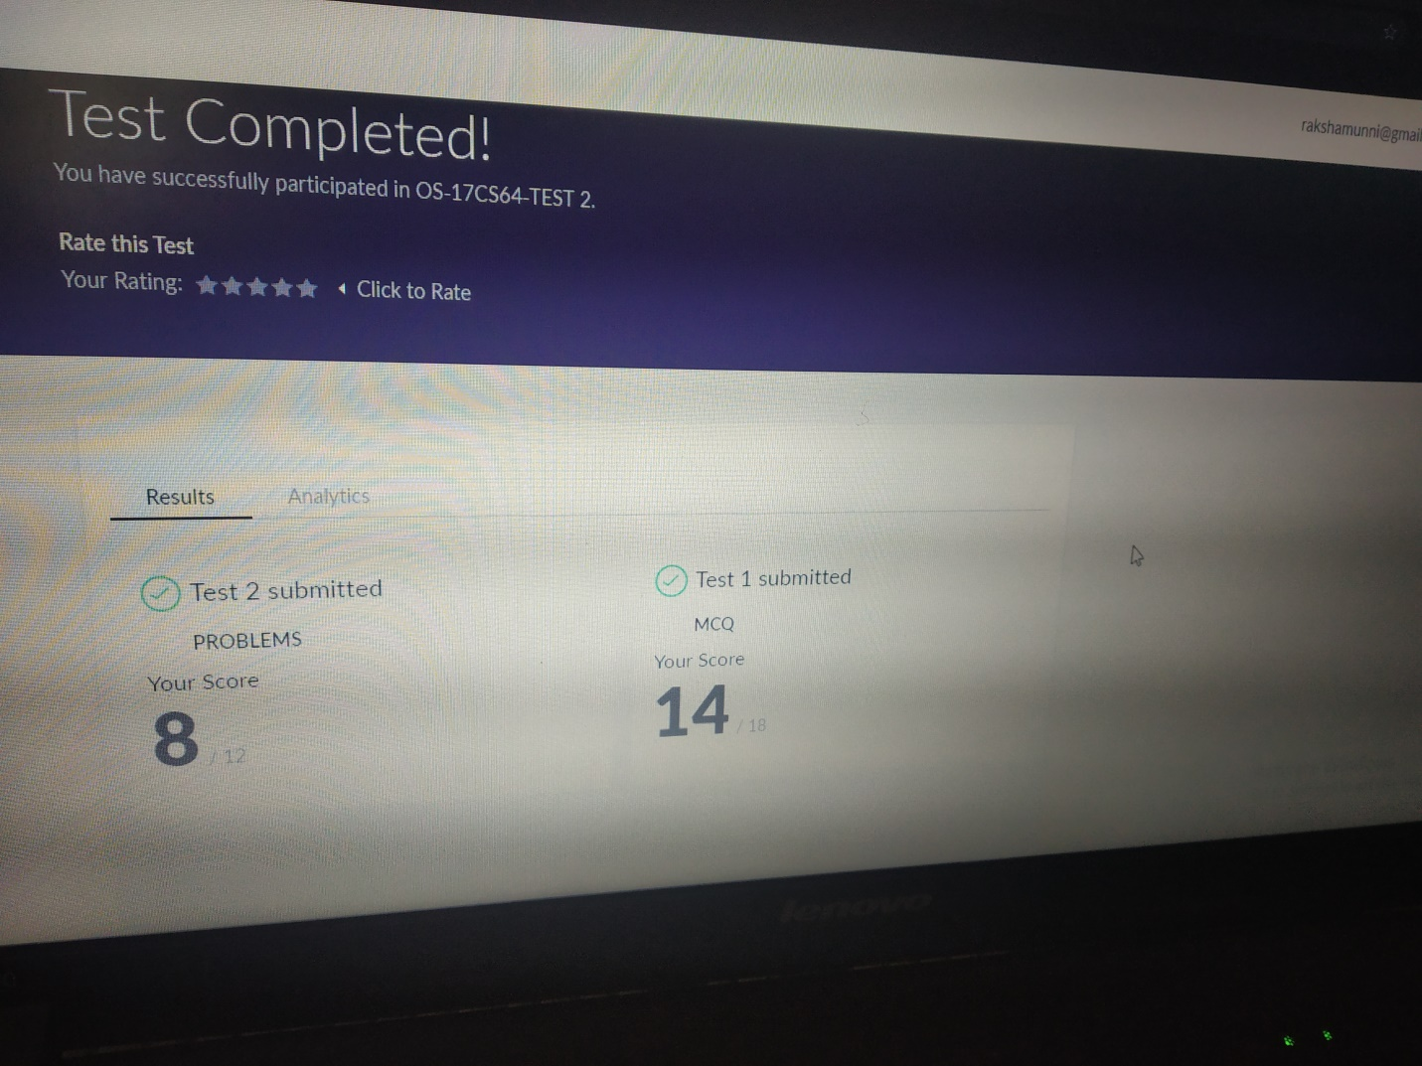

Scored 22 out of 30 in OS 2nd I.A test

Certification Course Details:

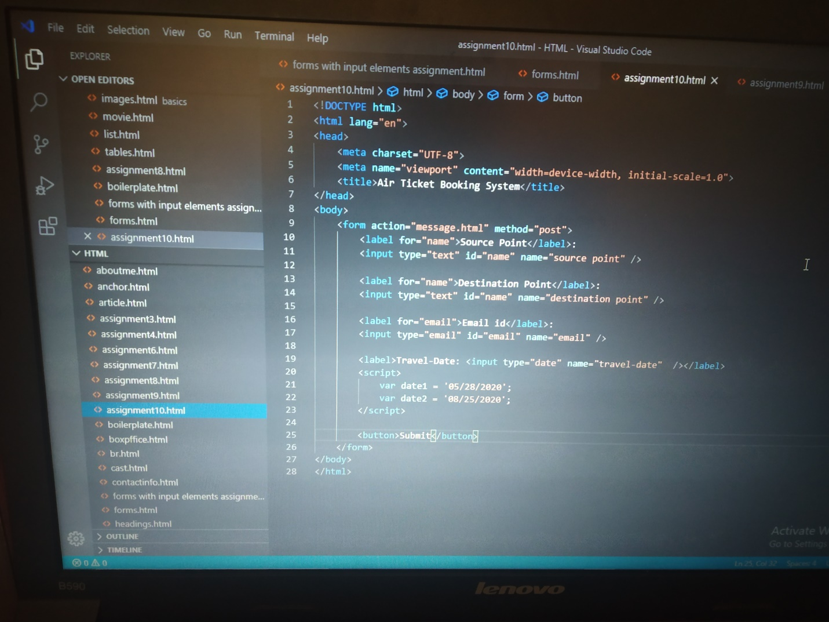

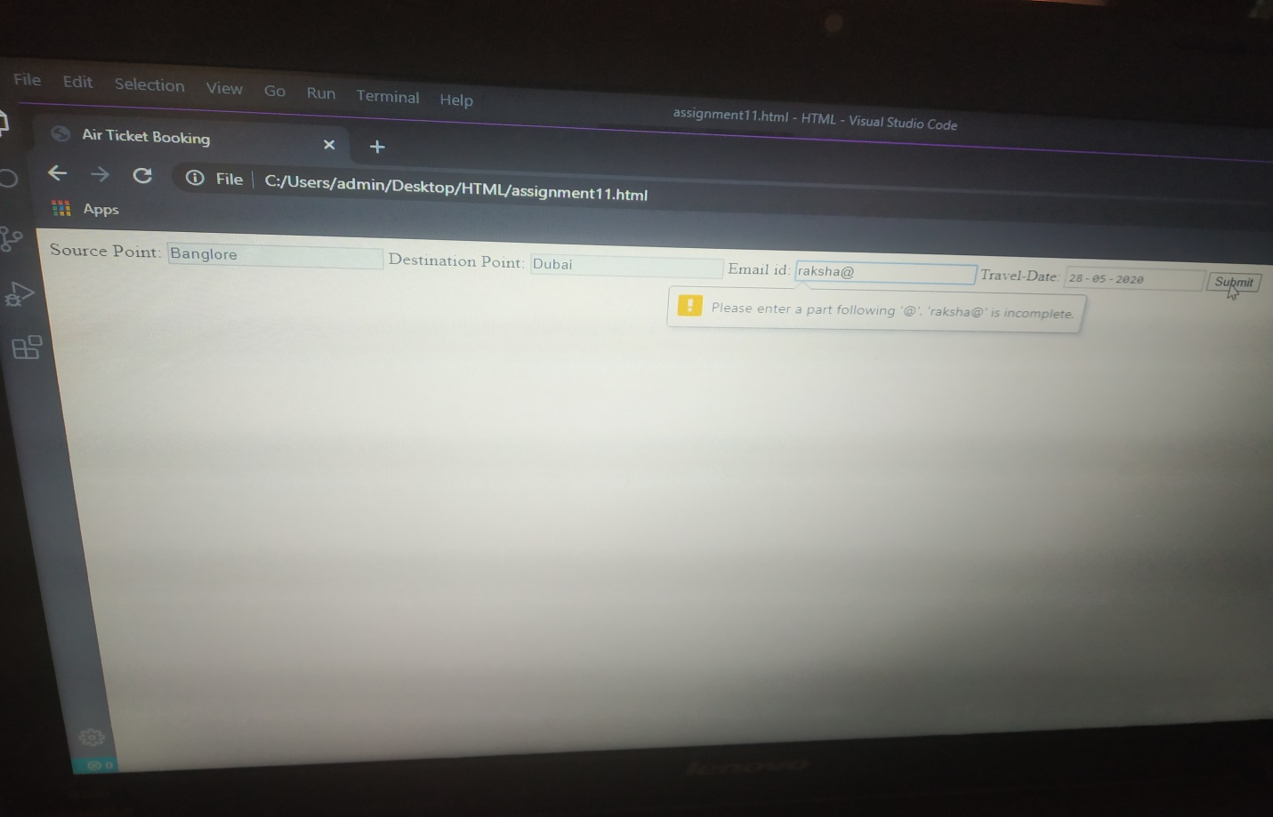

The above course is being taken up by me is based on FullStack Webdevelopment. Today in online course there was an assignment to create an Air Ticket booking form using form input,key elements and was asked to display an error in email when u give invalid mail.Above is the output where there was an invalid mail.

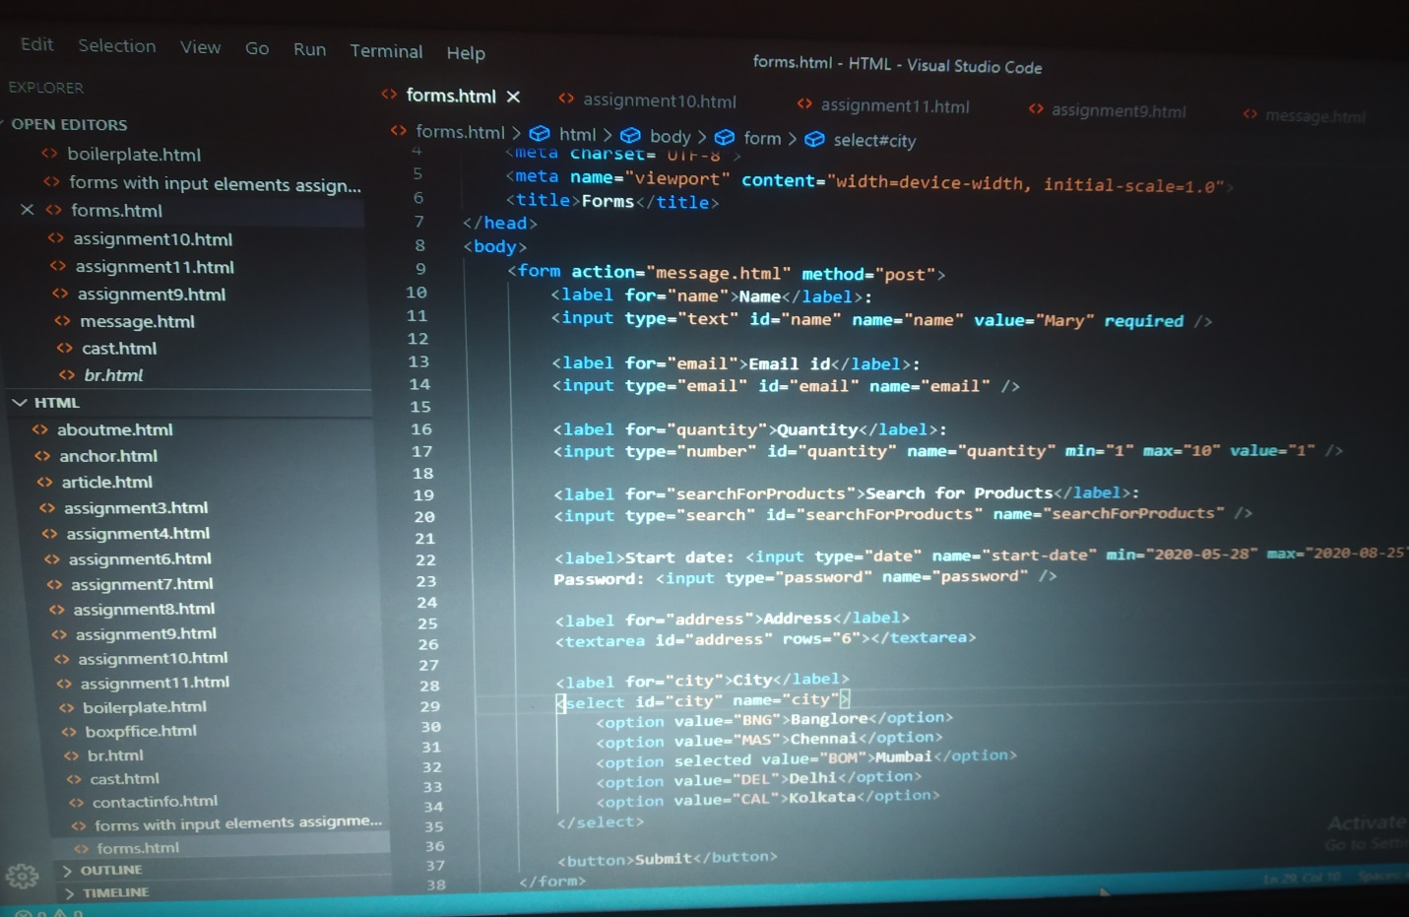

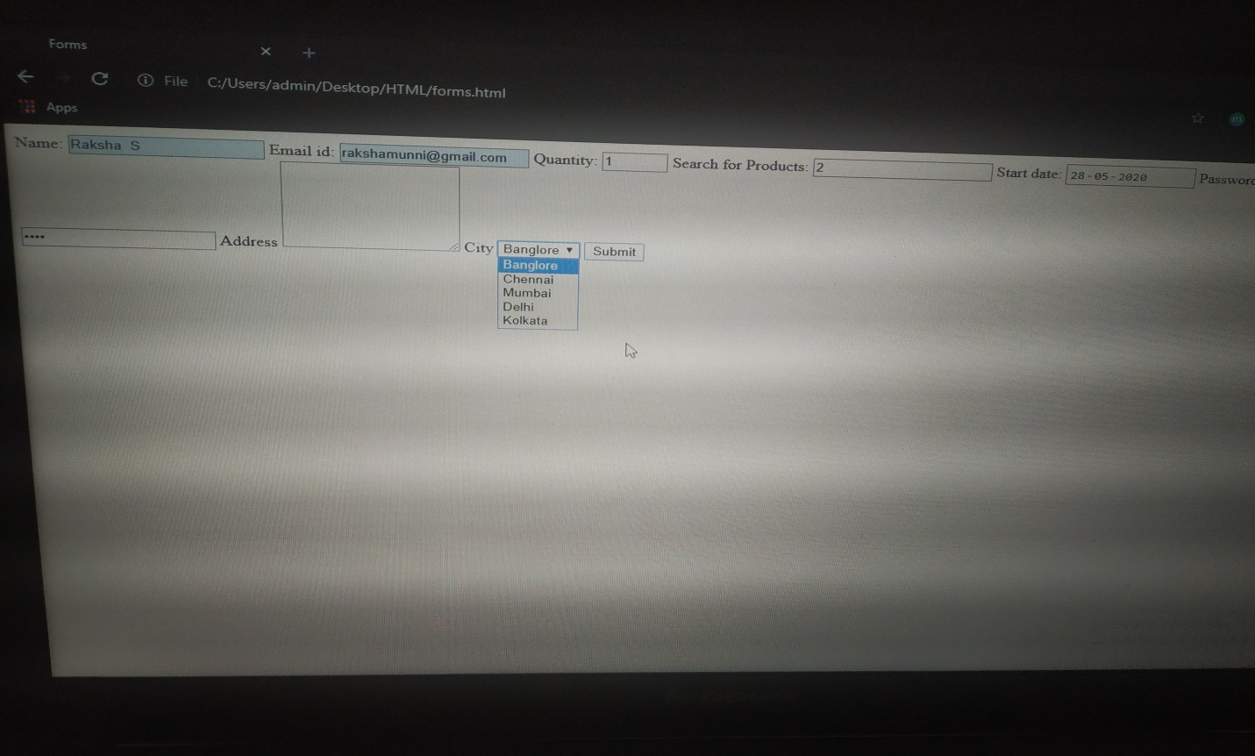

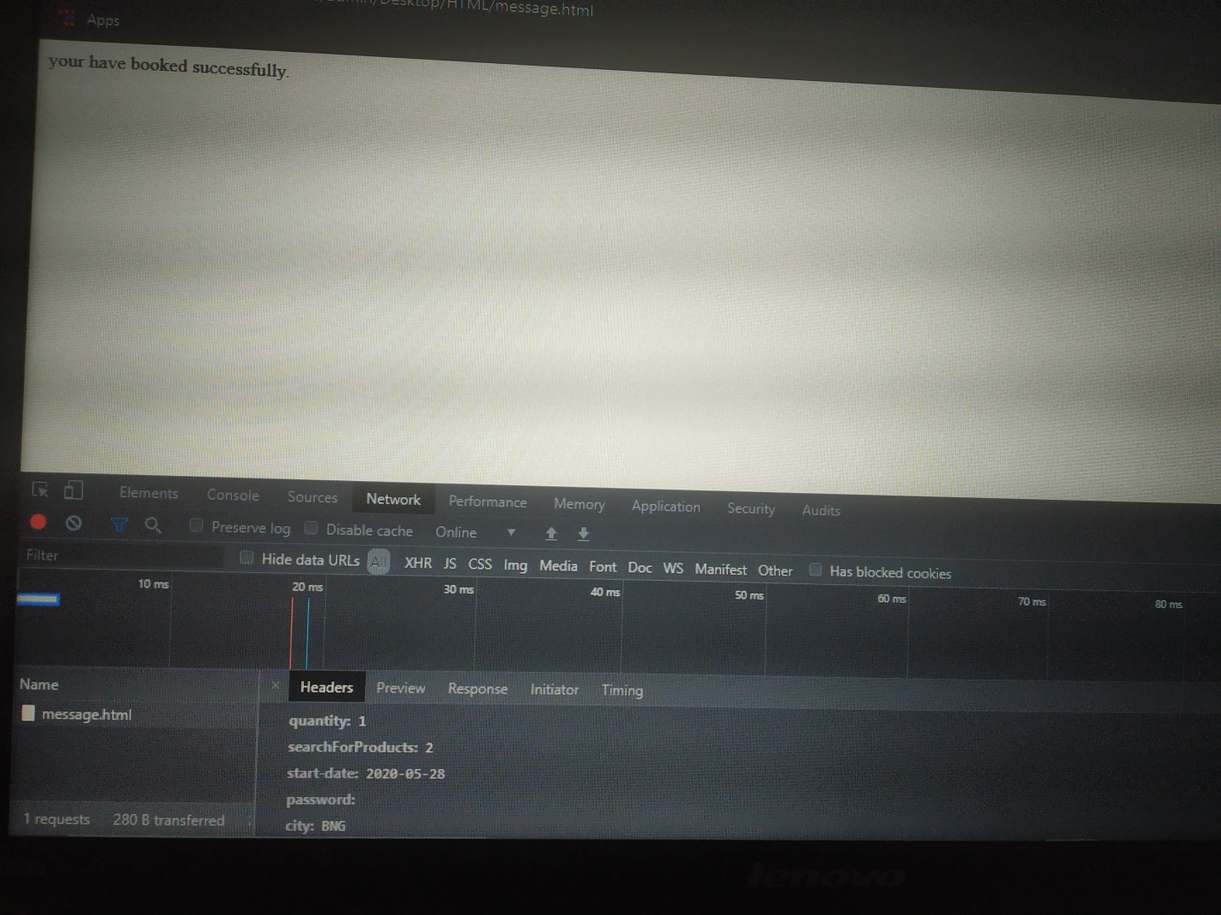

Above is the code of forms where in today I learnt different form tags.Dropdown values,selected value, password, date, quantity, email, name, text area, name etc.If the selected city should not be shown in the backend code we can use vaue=”BNG for banglore as example.

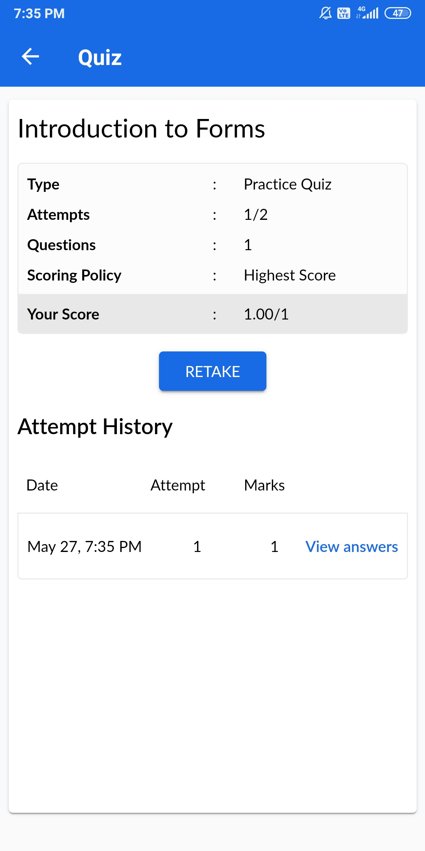

Coding Challenges Details:

Program1:

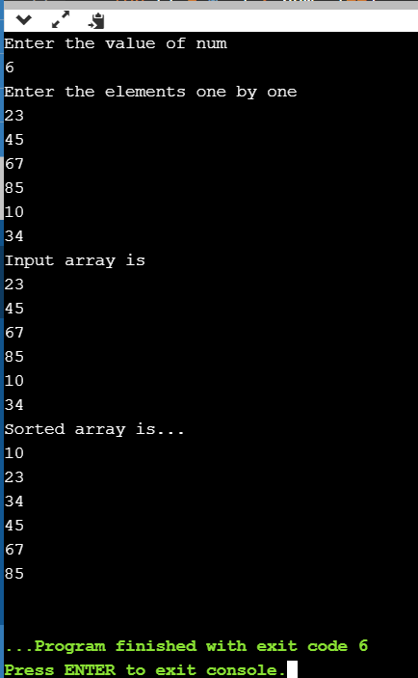

Program2:

